Module 7 – Final Project:
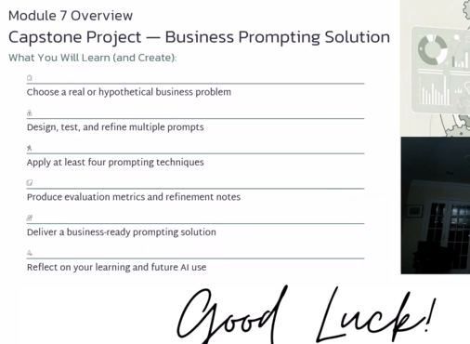
https://www.youtube.com/playlist?list=PL0EdWFC9ZZrUEjREzu8q9_KduLw9WDtiu
https://www.mckinsey.com/capabilities/operations/our-insights/gen-ai-in-corporate-functions-looking-beyond-efficiency-gains
https://www.harvardbusiness.org/insight/gen-ai-fluency-at-work-how-proficiency-drives-productivity-performance-and-learning/
https://mitsloan.mit.edu/ideas-made-to-matter/7-lessons-early-days-generative-ai
https://www.accenture.com/en/insights/ai-data/front-runners-guide-scaling-ai?country=US


